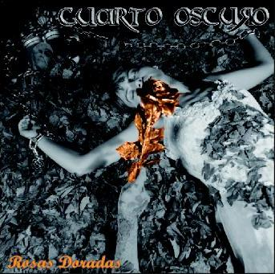
ROSAS DORADAS, A GOOD BEGINNING

CUARTO OSCURO still has one short history that begins in Marcilla (Navarra, North of Spain) toward end of 2005, when four musicians originating of bands like Peta Z or Desafio, found that they had the sufficient points in common like initiating a new adventure.
LJ (voice and bass), Oscar (guitar and choirs), Txiki (guitar and choirs) and Mikel (drums) went all the 2006 locked up in their home in Marcilla giving form to his first songs and polishing a style that finally stayed defined as "rock metal".
2007 were the year in which they occurred to know with one first 6 songs demo and a total of 20 concerts, including the supporting to the North Americans The Chelsea Smile in Lekunberri.
The running was satisfactory until the point that called the attention of the agency of management "Rock Star Management" and they were seen ready to lock in itself in the Recording Study Sonosfera in Calahorra (La Rioja - Spain) to take place they themselves and to record the one who already are their debut disc.
SONGS THAT DO NOT LEAVE INDIFFERENT
"ROSAS DORADAS" they are 11 intimist songs of forceful rock with melódic voices and letters between which they call the attention powerfully the adaptation that has made of the most popular "SILDAVIA" of La Union (impossible not to pay attention to it) or the penetrating "CAMALEÓNICA", one of those songs that you do not know so that, but that it ends up nailing in matería gray. Attention to “FACIL DE AMAR".
Of both songs we will have videoclip. The one of "SILDAVIA" in the old train station of Marcilla (Why go away?) and in natural scenes, it counts in addition on the collaboration to friends of the group.

promo@psm-music.com  www.psm-music.com  www.myspace.com/psmmusicbcn | 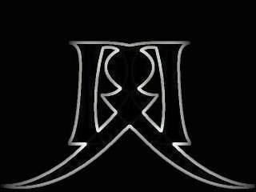 | Loscuartooscuro@hotmail.com  www.cuartooscuro.es  www.myspace.com/loscuartooscuro
PVP (recomended) 10 € - distribution: www.discmedi.com - PSM-31216-CD - 8435015510473

