
Dani Molina Quartet, learning every day a little more
With Perico Sambeat as a teacher, Dani Molina (sax) moved from his native Valencia to Barcelona to learn jazz and classical musician working as of this past ten years that has not stopped Dani Molina accumulate knowledge and experience as a musician.
Match the theme of jazz, Dani set up his group in 2003 with Pere Arguimbau (guitar), Joan Solà-Morales (bass) and Ramiro Rosa (drums). From the first time have mixed jazz standards with original compositions of any member of the quartet.

With this group have made many live concerts and have participated in international festivals such as Menorca, the Voramar Music Festival, the 15th Festival of Creative Music and Jazz de Ciutat Vella in Barcelona, in addition to being finalists in the Competition of Jazz Sala Montjuic.
It was precisely because of their participation in the International Festival of Menorca, which were presented with a chance to record their first album "Toc Toc" (2006) live at Sa Clau the Board of Ciutadella (Menorca Island).

ÀFRICA, a 2nd disc that reaffirms a trend
Four years later DANI MOLINA QUARTET present their second album "Àfrica", an album which clearly shows the evolution of this great jazz band that every day looking forward, innovating and renewing, always with respect. His melodies are intelligible, with bases and direct energy, with authority, control and modernism, and with a sound very Mediterranean with
an electric shock.
Being mostly instrumental pieces which assumes that the listener receives may have nothing to do with what originally inspired the composer. Thus, "Recés" (Pray) we can carry a story of intrigue developed in the old district of a populous Arab city, "La Serp" (The Snake) sounds more cosmopolitan, I suggest a rainy night in New York or "Àfrica", with a beginning of free jazz that gives way to a tribal fight brass instruments in the saxophone and trumpet to struggle to survive.

The disc closes with a surprise bonus track, a cover from the REM classic "Losing My Religion" for which they had the voice of María Lorea. The record also helped David Pastor
(trumpet) and Pau Domènech (bass clarinet).
David Molina says: "Dani has the power to confront their own (sax) in a very contemporary, but which can be seen glancing taste for boppost hard bop tradition, with attacks and cadences filled notes that are modulated by the strength or weakness of his phrasing, and thus obtaining an effect of remarkable authority, control and modernism "(Andréu Fàbregas).

promo@psm-music.com | 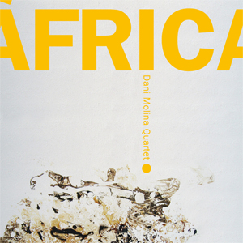 | joan_solam@hotmail.com
www.psm-music.com/danimolina |  | www.myspace.com/danimolinajazz
www.discmedi.com – 8435015511739 – PVP (recomended) : 10 €

