
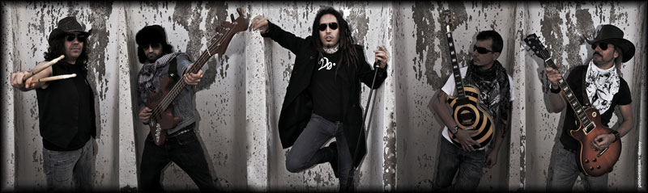

DOQUIER intruduce us his 1st EP "Todo a gritos"

Doquier (Everywhere): (spanish word) means everything that is around us

DOQUIER born in Barcelona in 2006 "the need to release feelings and use music as a means of expression and lifestyle, to their particular point of view in this world through Rock'n'Roll". Nobody said would be easy, because: writing songs, define a style, undergo changes in training ... is always complicated. yet the group was exceeded due to natural evolution.
In April 2011 DOQUIER now have the definitive: Marcos - voice, Diego - guitar, Alberto - drums, Javi - guitar, and Paton - bass, and began to precipitate events ...

It’s DOQUIER time

So far their actions had been told, as if it were reserved for what was about to happen. In October 2011 came second in the Wolfest in Razz 2, which won the Myspace Award, which led them to play in successive Bikini and give concerts. There was definitely DOQUIER time.
Later that same year, met with renowned guitarist and producer Miguel Pino to shape his first album. The result is a concentrated dose of Rock & Roll EP format (5 songs) entitled "TODO A GRITOS".
As the group put the finishing touches to the recording in the studio, it is noteworthy concerts in the Mephisto, La Sala ... among other places important in the music scene.

"Vacío sin nada" & "Prevalece" preview by DOQUIER

"Vacio sin nada" is the advance hit single by DOQUIER chosen as their first album, a song with ascending strength and forcefulness. The advance is completed with "Prevalece", another good shot whose chorus sound power, as its title indicates, it is difficult to forget.
In summary, the EP "TODO A GRITOS" is a balance of classic Rock'n'Roll where vocal melodies and guitars competing with each other, and together with a great rhythm section, complete a perfect cog in the band's sound, conveying their vision to the public in a proper way.

In addition to hearing their EP "TODO A GRITOS", now it does not miss a live DOQUIER and like them, go for ... the Rock'n'Roll.

www.psm-music.com/doquier  promo@psm-music.com | 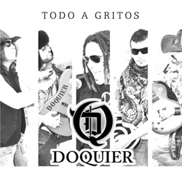 | www.doquier.es  doquier@live.com

PVP (recomended) 5 €- 8435015513252 – records shop distribution: www.discmedi.com (Spain)

