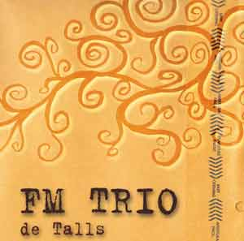
FM TRIO, well done jazz with Costa Brava flavour
FM TRÍO is a jazz band born in such a special place like the Costa Brava, in particular in Blanes in 2002 and consists of three renowned musicians in the spanish jazz scene: Fernando Morer (guitar), Oriol Casadevall (bass) and Juanma Morer (drums).
They have participated in festivals such as the Ciutat Vella, Banyoles, Arenys de Mar, Blanes Figueres o Blanes.

His repertoire consists of original compositions can be framed as contemporary jazz, though they have no objection to make their personal mark on jazz classics such as "What a wonderful life" popularized by Louis Armstrong or standards such as "Can ' t help falling in love with you "Elvis Presley and can be heard on their MySpace.

De Talls, contemporary jazz without complex
This, their first album, entitled "De Talls" is in his own words: "a series of subjects and some stardard versioning for us. On this record we intend to find their own sound, modern and staff to reflect our musical influences as well as our life experiences. So our sound is so intimate and powerful. In short, we have tried to join a music jazz, pop, Brazilian music ... and emotions”.
From the 11 pieces in the record is difficult to highlight just one. Own light shine "Mis Manias" in which he participated Xavier Molina on tenor sax or "En media hora", both composed by Fernando Morer, covers of the classic Louis Armstrong or above Elvis Presley, "Valía la pena" in which Esteve Dalmau has put his guitar or the piece dedicated to the road often traveled between Blanes to Castelló d'Empuries “De Blanes a Castelló”.
“De Talls” is an album produced by patient and attention to detail, finished recording in late 2009 at the Estudi 5 Grama, and leaving to stand up now that finally sees the light.
promo@psm-music.com | juanma_lia@yahoo.es
www.psm-music.com/fmtrio | Www.myspace.com/fmjazztrio
www.discmedi.com – 8435015511722 – PVP (recomended) : 10 €

