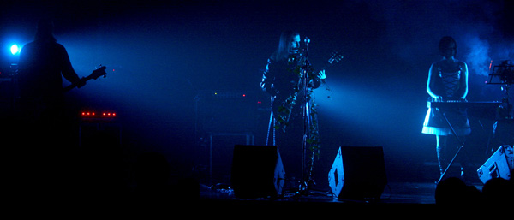

LÁUDANO presents preview from his 3rd disc “Lucifer”
“El Sonido de las Olas”

Under the name of LAUDANO are the personal project of a 30 years old musician and composer named Alberto Díez. But lest anyone think that this is an experiment or a fad, the disc has now LAUDANO and is the third of his career.
A path is certainly bound in the gothic rock scene, while trying to escape the label to avoid pigeonholing and have the freedom to guide their compositions without any corset.

Alberto himself talks about his origins: "My first steps in music began in 1991 when he won a contest and I start writing my first songs. After this became part of the group Dark limit where I work as a composer and guitarist (pop-rock practiced decaf), I stay until 1997, when at age 16 decided to start my journey alone, giving life to what is now laudanum". "I grew up hearing my parents albums ... Pink Floyd, Genesis, Electric Light Orchestra, Boston, etc ... thus reached a point where you wanted to know if I would be able to do the same to them, I tested me, and started writing music.".

Dark and neoclassical gothic self-taught

Almost self-taught, and loneliest runner "A couple of years I studied music theory, composition and guitar. The rest I learned on my own, with the passage of time and experience music." "My musical tastes are diverse, it is true that I have my favorites, but it really is life itself that inspires me to compose the music I write ... I am a very emotional person, and I eat and experience of human feelings around us. as for my musical tastes, could highlight artists and bands that have influenced me (Lacrimosa, David Bowie, Depeche Mode ... even Mozart and Bach) but I'm open to all kinds of quality music. in the literary terms, I like the eighteenth and nineteenth authors like Le Fanu, Bierce, Edgar Allan Poe ... and more contemporary in a philosophical branch".
LÁUDANO’s music it’s an stright attack to heart & mind
At this point, LAUDANO present their third album entitled "LUCIFER" and that by way of advancement, now appears only digital EP with two versions of "EL SONIDO DE LAS OLAS" (disk and edit versions) and "Hubo un tiempo atrás". Step prior to the start of the presentations that will lead to disparate points of geography. It will inform you of them. "I'll take care of all instruments and production in my own studio. In direct relation to the story with the help of Roberto Santos on bass and keyboards to Monica Camarero". LAUDANO uses dreams to communicate through music a simple message ... that there is a
this parallel life in which we can be much more than we think.
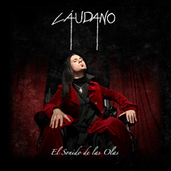 | www.laudano.com  info@laudano.com  http://laudano.bandcamp.com  www.psm-music.com/laudano  promo@psm-music.com

