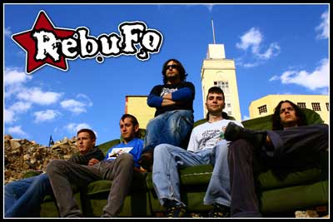
...the decision that changed his lives

Ontinyent (València, Spain), 2003. A group of friends without any idea about how to play an instrument, take a decision that will change its lives...
REBUFO it’s just born. "adolescent innocents who looked for some way to fill all along free that there is when practically you do not have anything to do". What in the beginning single they were unconnected noises, they were taking form from songs simultaneously that its ability with guitars, bass, drums and others improved day to day. The covers from E.U.K.Z, La Polla, Nirvana, Agua Bendita or Porretas went opening the way to their own songs....

June 2004: Its first live concert, with Sinestesia and Malos Vicios. It had to come out well, because since then they have not stopped to play live, to play, to play and to play...

Small adjustments in the band that finally is made by: Mero (guitarr), Eloi (drums), Xavi (guitarr), Naxo (bass) & Pello (voice)...

A BRINCOS CON LA LUNA, a reflection of personal experiences

In November 2007 they are locked in the Groove Studies in Alcàsser (Valencia) with Naxo Menxeta, in the sound table, to give form to its disc of debut that takes by title "A BRINCOS CON LA LUNA", phrase removed from its song "A Rebufo".

“A BRINCOS CON LA LUNA” it is a full disc of generosity. In the recording they have counted with special collaborations of its "colleagues", so Joda (from Eppi) puts the voice in "Años de Lucha", Victor (from Malos Vicios) sings in "Volar", Santi (from Mal Abuso) does a guitar solo in "Mi Canción", Lluis puts his in "Años de Lucha", Carles (from L'Home del Sak) contributes his trombón in "Un día cualquiera", to which Pauel (from Tashkenti) also contributes the trompeta and Pedro (from L'Home del Sak) has put saxo in "Mi Canción".

According to its own words: "We sounded to ourself". REBUFO is a mixture of rock, urban rock and punk. The list of its confessed influences, already contributes some track to us more: Extremoduro, El Último ke Zierre, Barricada, Los Suaves, Platero y Tu, Reincidentes, La Polla, Green Day, etc..

The songs that compose this disc speak of different subjects, in most of the day to day of their lives, usually are the personal experiences those that inspire to them to write. "Mi Canción", relates laziness and boredom that sometimes wins to them, but at the same time does not leave of side the illusion and the good roll that can transmit to them to listen to a song. "A Rebufo", the ballad, of thematic loving but full of rage. "Volar" speech of how always it is necessary to risk to make the things by one same one. Most hopeful anyone is "Un dia cualquiera", that it invites to us to sail with them until the horizon, on the contrary, "La Muerte" relates the lowest possible mood, without leaving of side the rage that tries to show in their letters although they speak of negative things. And already finishing, "Por otros caminos" perhaps the song with the pegadizo refrain, the smoothest song but than gives a special touch him to the mini-album, and that speaks of how everything can change when you are suddenly with a bifurcation of ways, and you choose less honest. And we finished with the powerful song, with good dose of double pedal "Años de lucha", that speaks of as the day to day is a fight by the R'n'R, on how it is lived more at night than by day and of which in the years that will come we will follow equal.
You will se in the bars...
& will listen in this mini-álbum with 7 songs that they call EP.

www.psm-music.com/rebufo  www.myspace.com/psmmusicbcn  Promotion:  promo@psm-music.com  Distribution:  www.discmedi.com | 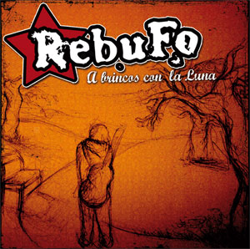 | www.rebufo.com  www.myspace.com/rebufo  Contact with the band:  rebuforock@gmail.com
PSM-31193-CD | Bars code 8435015510053 | PFS (recomended) : 5 €

