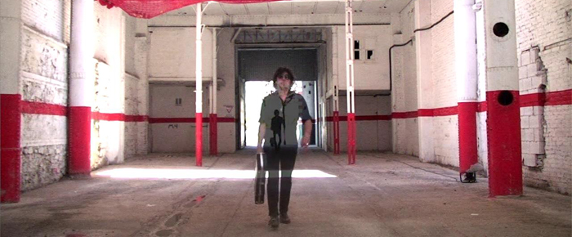
SOTOS presents “VUELVO A ENTRAR” with friends

The name SOTOS may sound like a new one, but if we investigate a little beat, we will see that this is Juan Carlos Sotos, an artist known and respected among his peers and among the connoisseurs of the music scene.
Originally formed part of La instalation and Los Molestones, but went with his group LA ROCKA with whom he began to carve a "name" the music journalist Caesar Campoy even said that "To speak about La Rocka is talking about the history of music in Valencia". As La Rocka recorded two albums and play with Simple Minds. Even Jaime Urrutia himself noticed the talent of his songs and recorded SOTOS songs "Mentiras", "Si la vida te lo da" and "Tus problemas" and incorporating it as a musician in his band along with other prestigious musicians: Esteba Hirschfeld (ex Manolo Garcia’s Los Ràpidos), Juan Luis Ambite (ex the Pistones) or German Vilella (ex Los Rodriguez).

But SOTOS is a prolific artist, restless and with great creativity, as well as play along with his friend Jaime Urrutia, has to find an alternative way to vent their concerns, and that path is his own band, "SOTOS" with which recovers the spirit and essence of rock & roll.

A disc of ROCK & ROLL with a TOUCH OF CLASS

"Una noche más" was the song chosen as an advance presentation of the CD, a piece of rock that has counted for much in the disk as in the video with assistance from his friends, Esteban Hirschfeld and Jaime Urrutia. Coinciding with the release of the album, the new "hit single" is "SOBREVIVO" which has also made ​​a video clip produced by Marino Dares and Edu Hirschfeld.

VUELVO A ENTRAR is a collection of 11 songs that eveutime you listen it you come to the conclusion that "it has been carefully worked" ... lyrics, arrangements, collaboration, including the order in which attention to detail is sounding like a concert staged thousand times and not missing the "artists / friends guest" and we discover as Jaime Urrutia (courtesy of Warner Music Spain) put vocals on "Es Amor" and "Una Noche más", Ariel Rot (courtesy of Warner Music Spain), voice and guitar in "Ni tu ni yo" and only guitar on "Vida irreal", Ruben & Leiva (courtesy of Sony Music) acoustic guitars in "Mentiras", Jorge Explosion puts the harmonica on "Tus problemas" Esteban Hirschfeld and all kinds of keyboards in five of the subjects. The result is an album of rock and roll with a nice touch of distinction.
SOTOS, the band, is formed by Javi Sevilla at drums, Jorge Silvestre at bass, Luis Machado at guitar, Quique Ballester at guitar & Juan Carlos Sotos at main voice and guitar.

promo@psm-music.com  www.psm-music.com/sotos |  | jsotosgarcia@gmail.com  http://jsotosgarcia.wix.com/sotosband  Management:  rherraiz@produccionesboulevard.com
psm-31281-cd – 8435015512996 -PVP (recomended) physical copy : 10 € digital : 5 € - records stores distribution: www.discmedi.com

