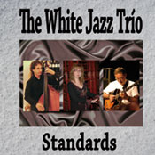

THE WHITE JAZZ TRIO
Standards

After several previous musical experiences, in the spring of 2009, Noelia White gave way to The White Jazz Trio as we know it today, but before he had a quartet.

...sliding down swing slides

Noelia White has training in choral music, modern music and jazz, among others has been part of the Barri Gotic Blues Band, Night & Day and has even formed his own orchestra. Music teacher as the other two members of the trio, this album has been allowed the luxury of doing what you like, sliding down swing slides and give his very personal touch to these songs that we've all heard at one time and Noelia’s voice take on new shades.

In this new adventure Pep Casadó accompanying on guitar, professional musician since 1988, music teacher and responsible for the arrangements of the songs on the album and the bass René Dossim with a number of experiences in other groups.

Good calification with a demanding repertoire

As the traks of "Standards" advancing, including jazz listener unaccustomed to following melodies will be surprised that he knew as "How High the Moon" made popular by Ella Fitzgerald, a couple of tracks by Antonio Carlos Jobim, "One note sambla" and "Por causa de voçe”, one of Gershwin's "But Not For Me" from the 1930’s musical "Girl Crazy", "My Funny Valentine" also from other musical "Babes in Arms" performed by Frank Sinatra and Miles Davis or the classic, "Take Five" by Paul Desmond with putting the final point.

Dare to topics that may be tempted to compare versions of big names in jazz of all time, is not something that is open to anyone and in this case The White Jazz Trio get the best of califications, thanks to the talent and passion for the swing of its members to make themselves and their audience to feel like an old jazz club in New Orleans in a black & white police’s movie.

www.psm-music.com/thewhitejazztrio | 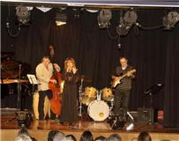
promo@psm-music.com |  | noeliawhite@hotmail.com
PVP (recomended): 10 € - 8435015512156 – PSM-31259-CD – Distribution: www.discmedi.com

